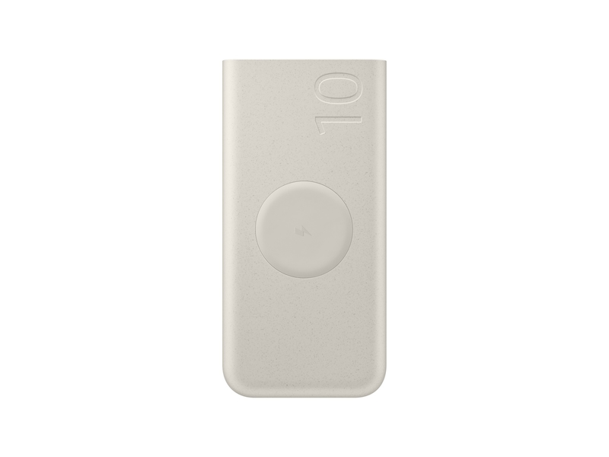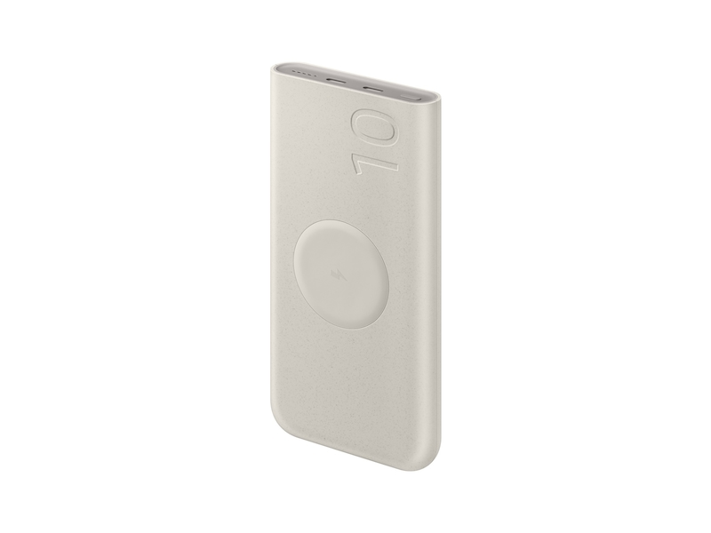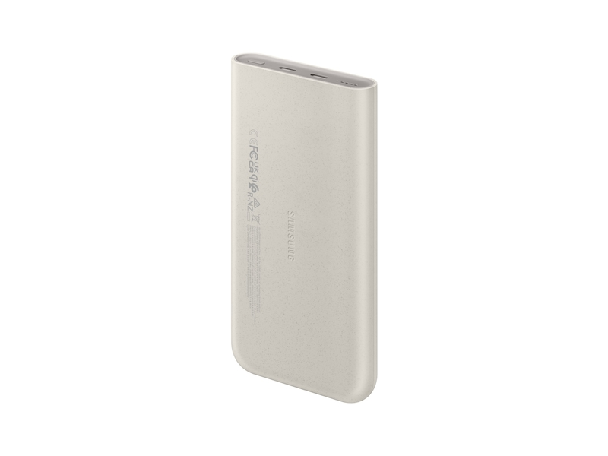

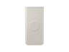

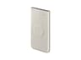

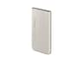

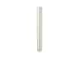

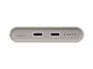

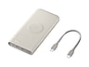

**Samsung.com Advantage**



**Pay in 4 installments**

https://image-us.samsung.com/SamsungUS/PIM/icon_store.png

**In-Store Pickup available**

**Free, No Contact Delivery**

**VIP Advantage**

**VIP Advantage membershipLearn more**

* 2 Year Samsung Care+ (without Theft and Loss)
* Exclusive Discounts & Early Access

To select this option, please sign in or create a Samsung account

**Premium Benefits**

**$149.99/yr**

**Delivery & professional services**

Availability for:

10001

Delivery

**Delivery**

Get it by Dec. 23



**In-Store Pickup**

Get it **Today**

**Choose your purchase option**

https://image-us.samsung.com/SamsungUS/pim/Icon_chat_new.png?$default-png$Questions? Ask a Financing Expert

**One-time Payment**

**$35.99**

**Pay in 4 Installments**

**$9.00**

**every two weeks σπ**

**One-time payment**

Pay with your credit card, debit card or a pay app. Excludes taxes and shipping.

**25W 10,000 mAh Wireless Battery Pack, Beige$44.99**

Instant Credit

**$9.00**

**Total**

**$35.99~~$44.99- original price~~**

**You Saved Today$9.00**

rewards

**Log in now to earn up to 1.5% back in Samsung Rewards Points**

**Add to cart**

[**Where to buy**](https://www.samsung.com/us/mobile/mobile-accessories/phones/25w-10-000-mah-wireless-battery-pack-beige-eb-u2510xuegus-buy)

Buying in bulk for your business?

[**Go to 25W 10,000 mAh Wireless Battery Pack, Beige for Business**](https://www.samsung.com/us/business/mobile/mobile-accessories/phones/25w-10-000-mah-wireless-battery-pack-beige-eb-u2510xuegus/)

Supported payment types:

Credit CardPayPal Venmo Checkoutamazonpaygooglepay

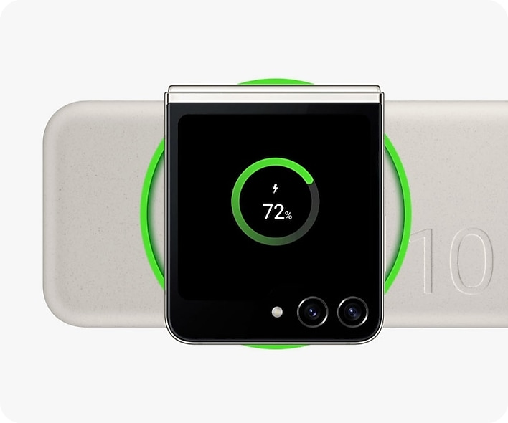

**Wireless power  
on the go**

With a convenient wireless charger, s imply place your device on the wireless battery